Architecture Description of Java-Based Learning Management System (LMS)

For Advanced Software Engineering Project 2024
This document follows the ISO/IEC/IEEE 42010:2011 standard.

1. Introduction

1.1 Identifying Information
This architecture description outlines the design and structure of the Java-Based Learning Management System (LMS), a web-based application for online course management and assessment. The LMS employs a monolithic architecture style.

1.2 Supplementary Information
Date of issue: November 2024
Authors: Team Members (IDs provided in submission)
Project Coach: TA
Version: Phase 1

1.3 Other Information

1.3.1 Overview
The LMS is designed to streamline course creation, user management, assessment, and performance tracking. It consolidates all functionality into a single application for simplicity and efficiency. The architecture includes a user interface layer, business logic layer, and data access layer, all interacting with a centralized database.

1.3.3 Rationale for Key Decisions
The monolithic architecture was chosen for its simplicity and rapid development capabilities. Although it imposes constraints like tight coupling and limited scalability, it aligns with the project’s moderate concurrency requirements and scope.

2. Stakeholders and Concerns

2.1 Stakeholders
1. Students: End-users accessing courses and assessments.
2. Instructors: Users managing courses and grading assessments.
3. Admins: Users overseeing system settings and managing other users.
4. Developers: Responsible for implementing and maintaining the system.
5. Maintainers: Addressing system updates and fixes.

2.2 Concerns
1. System usability and accessibility for diverse user roles.
2. Robustness of user management and role-based access control.
3. Scalability to handle moderate concurrent users.
4. Data integrity and consistency in assessments and notifications.
5. Security of user data and authentication mechanisms.

2.3 Concern–Stakeholder Traceability
Stakeholder mapping to concerns is detailed in the following table:
1. Students: Usability, Notifications
2. Instructors: Role-based access, Performance tracking
3. Admins: Data consistency, Scalability
4. Developers: Robustness, Scalability
5. Maintainers: Security, Data Integrity

3. Viewpoints+

3.1 Functional Viewpoint
This viewpoint describes the functionality of the LMS from a user and system interaction perspective.

3.3 Concerns
1. How does the system support user roles?
2. How are courses and assessments managed?
3. How does the system handle notifications and reports?

3.4 Model Kinds
UML Use Case diagrams and sequence diagrams are used to model system interactions.

4. Views+

4.1 Conceptual View
The Conceptual View represents the LMS architecture at a high level, focusing on the primary modules and their responsibilities. It emphasizes the building blocks of the system without delving into runtime behavior or detailed implementation. This view answers questions such as:
1. What is the primary functional responsibility assigned to each module?
2. How is the system structured as a set of code units?
3. What other software elements can a module use?
Modules in this view include:
- User Interface Layer: Responsible for handling user interactions.
- Business Logic Layer: Manages core functionalities like user and course management.
- Data Access Layer: Handles interactions with the centralized database.
Connectors between modules represent associations, such as dependency or inheritance.
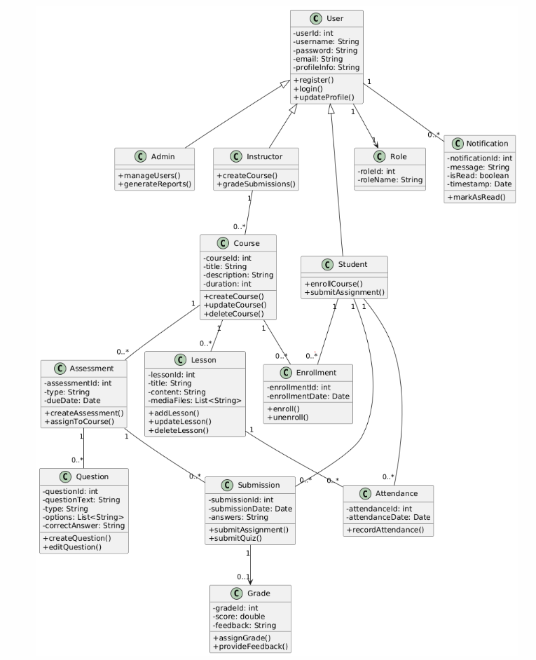

4.2 Use Case View
The Use Case View captures the interactions between users and the LMS. It identifies the major functionalities provided by the system to fulfill user goals. This view is represented using UML Use Case diagrams, focusing on:
1. User Registration and Login
2. Course Creation and Enrollment
3. Quiz and Assignment Management
4. Performance Tracking and Notifications
This view highlights how the system meets the requirements of different user roles, including Admins, Instructors, and Students, through role-specific functionalities.
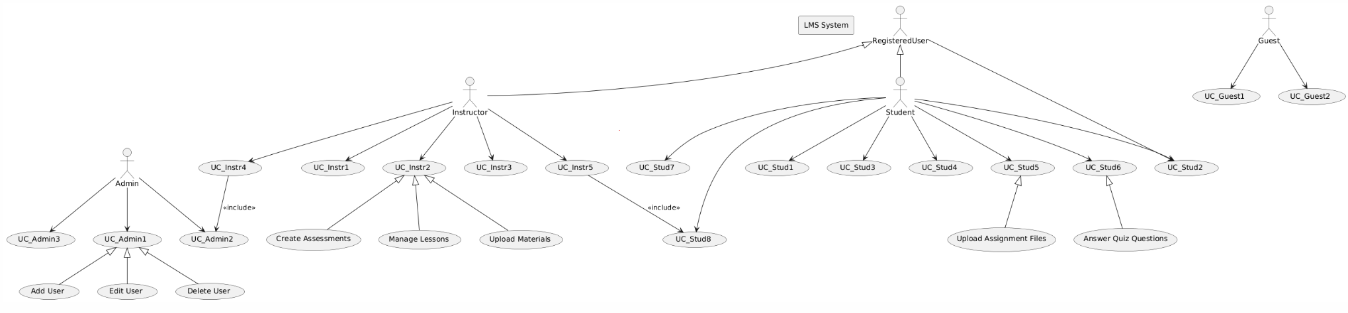

5. Consistency and Correspondences

5.1 Known Inconsistencies
No inconsistencies are currently identified.

5.2 Correspondences in the AD
Correspondences between layers and components are documented using UML diagrams.

Appendices

Appendix A: Architecture Decisions and Rationale
1. Decision to use monolithic architecture: Simplifies development and deployment.
2. Use of MySQL: Reliable and consistent for centralized database needs.
3. Role-based access control: Ensures security and targeted functionalities.

Appendix B: References
1. ISO/IEC/IEEE 42010:2011 Standard.
2. Advanced Software Engineering Course Materials.
3. Project Requirements Document.

Scenarios
Instructor Creates Course
- Login and Access: Dr. Lamia navigates to the login page, enters her username and password, and clicks the "Login" button. The system validates her credentials against the database. If valid, she is redirected to the course management page; otherwise, an error message prompts her to try again.
- Course Creation: On the course management page, she clicks the "Create Course" button, which opens a form. She fills in details such as the course title, description, and duration. Upon submission, the system validates the input. If validation fails (e.g., missing fields), an error message is displayed.
- Confirmation and Notification: If the data is valid, the system saves the course to the database and shows a confirmation message: "Course Created Successfully." Dr. Lamia also receives a notification about the course creation, either as a pop-up or dashboard alert.

Student Enrollment in a Course
- Browsing and Searching: Lamia navigates to the "Courses" section from the dashboard by clicking the "Browse Courses" button. On the courses page, she uses the search bar or filters to find courses based on keywords, categories, or instructor names. If no matches are found, a message appears: "No courses found. Please modify your search."
- Enrollment Request: After finding a course, Lamia clicks the "Enroll" button. The system checks if she is already enrolled. If she is, a pop-up error message appears: "You are already enrolled in this course." If not, a request is sent to the instructor, notifying them via an alert or email.
- Approval and Notification: The instructor reviews Lamia’s request and can either approve or decline it. If declined, Lamia receives a notification: "Your request to enroll in the course has been declined." If approved, she gets a notification: "Your request to enroll in the course has been accepted," and gains access to the course materials through the "My Courses" section.

Submitting an Assignment
- Accessing the Assignment: Yassin logs into the LMS and navigates to the "My Courses" section. He selects a course and goes to the "Assignments" tab, where he chooses the assignment, he needs to submit. The system redirects him to the assignment page, displaying details like instructions and due dates.
- File Upload: Yassin clicks the "Upload File" button, which opens a file picker window. He selects a file from his device, and the system validates the file type and size. If the file is invalid, an error message prompts him to choose another file. If valid, the file is uploaded, and a progress indicator is shown.
- Submission and Feedback: After uploading, Yassin clicks "Submit" to finalize the submission. The system updates the database to reflect the submission and displays a confirmation message: "Your assignment has been successfully submitted." Yassin receives a notification confirming the submission and may also get an email, depending on his preferences.
Taking a Quiz
- Accessing the Quiz: Yassin logs into the LMS and navigates to the "My Courses" section. He selects a course and clicks on the "Quizzes" tab. The system checks if the quiz is available. If not, it shows a message: "The quiz is not yet available" or "The quiz deadline has passed. “He selects the course for which he needs to take the quiz (for example, "Java Programming").
- Starting the Quiz: If the quiz is available, Yassin clicks "Start Quiz." A timer appears, showing the remaining time. The quiz page loads with various question types, such as multiple-choice (MCQs), true/false, and short answers. Yassin can navigate between questions using "Next" and "Previous" buttons.
- Submission and Results: Once Yassin completes the quiz, he clicks "Submit Quiz." The system prompts for confirmation before final submission. After submission, the system processes and stores the responses. If the quiz is auto-graded, Yassin sees his score and corrects answers immediately. For manually graded questions, he is informed that grading is pending.

Creating a lesson
- Accessing the Lesson Form: Dr. Ahmed logs into the LMS and navigates to the "My Courses" section from the Instructor Dashboard. He selects a course and clicks the "Lessons" tab. He then clicks "Create Lesson," which opens a form to input lesson details.
- Lesson Details: Dr. Ahmed fills in the lesson title, description, and uploads supporting materials like PDFs and videos. He reviews the details and clicks "Submit." The system validates the inputs and processes the request.
- Backend Processing and Notification: The system saves the lesson in the database and triggers the Notification Service to alert students about the new lesson. An OTP is generated for lesson attendance, and students receive it via notifications or email. Students can mark attendance by entering the OTP.
Removing a student
- Selecting the Student: Dr. Ahmed logs into the LMS and navigates to the "My Courses" section. He selects a course and clicks the "Students" tab. The student list shows names, enrollment dates, and progress records. Dr. Ahmed clicks "Remove" next to the student he wants to remove.
- Validation and Confirmation: The system checks for pending tasks, such as unsubmitted assignments. If no issues exist, a pop-up appears with the student’s details and a warning about the impact of removal. Dr. Ahmed enters a reason for removal and clicks "Confirm."
- Notification and Updates: The system updates the database to reflect the removal and logs the action for audit purposes. The student receives a notification with the course name and removal reason. Dr. Ahmed sees a success message, and the students’ records are archived for future reference.

